2021 CSA AGREEMENT FORM
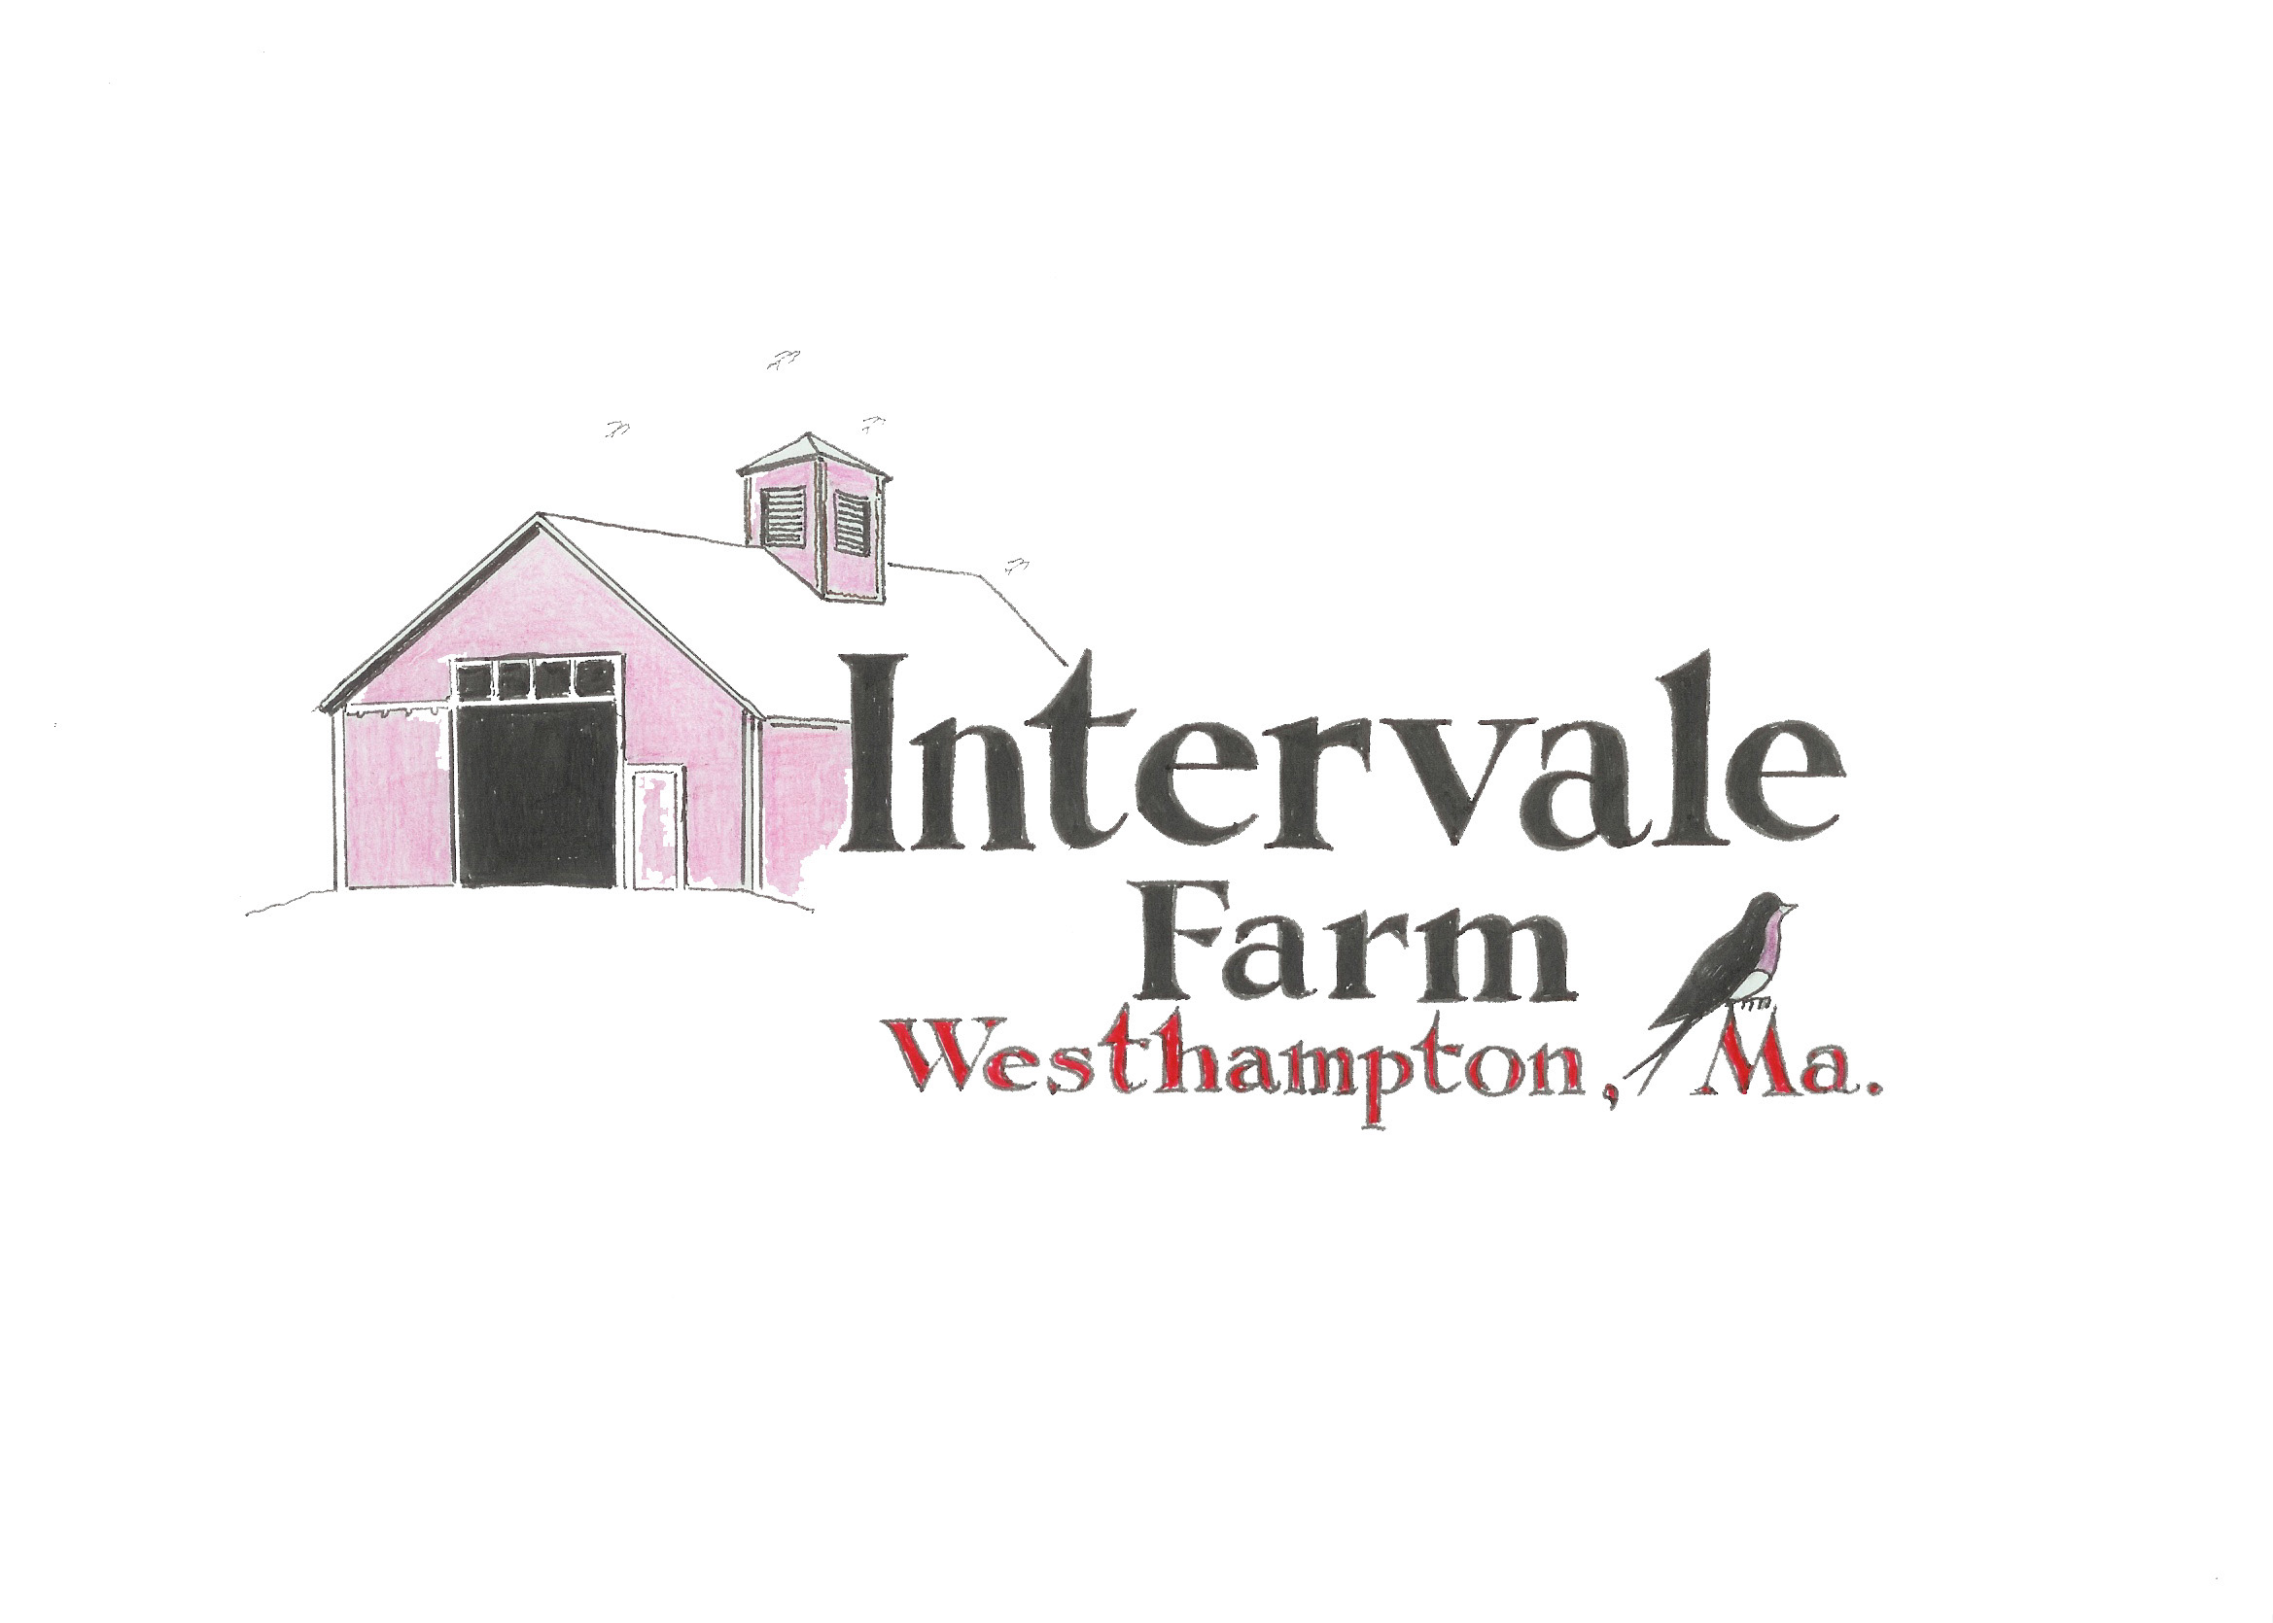
Shareholder

Name

Address

Home Phone e-mail

Membership Commitment

___ Yes. I wish to purchase a share in Intervale Farm CSA. 1 year @ $500
____ I wish to pay in full by March 1, 2021 $ 500

____ I choose the payment plan March 1 $ 165.00
May 1 $165.00
July 1 $170.00

____I choose a medium share 1 year @ $300 in full

___ I choose the payment plan March 1 $150
May 1 $150

____ I prefer Monday pick up 2 to 7 P.M.

____ I prefer Thursday pick up 5 to 7 P.M.

INTERVALE FARM
27 Cemetery Road
Westhampton, Ma 01027
413-527-5440
email - intervale5@comcast.net

